Jesse Speedy
DOS 522 Rad Dose Calc.
2/25/2017
Beam Attenuation Project: Wedge factor calc.
Objective: To determine the wedge factor for a radiotherapy treatment plan and apply that factor to the monitor unit calculation in an actual treatment plan.
Purpose: In radiotherapeutic treatment, standardized measurement processes are established to determine linear accelerator output. These standardized measurements are compared to output measurements for variable factors to determine the impact of variables on the treatment beam. For example, an unobstructed therapeutic treatment field output is measured to a standard depth of 100cm SSD at a standard field size of 10x10cm.¹ A wedge variable can be introduced under the same standardized conditions and output with the wedge can be measured and compared to the standard field and a wedge factor is determined.
By introducing attenuation devices such as wedge filters the dose distribution can be altered to benefit the planning process. Aspects of patient thickness and beam geometry can introduce inhomogeneites to a treatment plan, by adding a wedge those inhomogeneities can be accounted for and corrected. Wedge factor is an important value in the monitor unit calculation process the following exercise will demonstrate this.
The wedge factor can be found using the following formula:
Wedge factor= dose w wedge/dose wo wedge¹
Methods and Materials: In this exercise wedge output was measured on a Varian 2100IX linear accelerator. Field size was set at 10x10 cm. The linac delivered 100 monitor units (MU) at a dose rate of 600 monitor units per minute to a PTW ionization chamber model N30002 placed within a 10cm of solid water equivalent material. SSD was set at 100cm to the water solid surface. Additionally, 6cm water solid was placed behind the ionization chamber to absorb and reduce any backscatter. No buildup cap was needed on the ionization chamber due to the presence of the water solid material. An Inovision electrometer model 35040 set to a bias voltage of 300v to collect the charge and measure output. The aforementioned calibration was done in three trials utilizing 6MV and 10MV photon energy. Three measurements were done with unobscured fields of each energy and three measurements were done with a thirty-degree wedge. To ensure accuracy of wedge and ionization chamber alignment three additional measurements were taken of each energy with the wedge rotated 180 degrees.
Pictured below is the setup for the wedge output measurement:
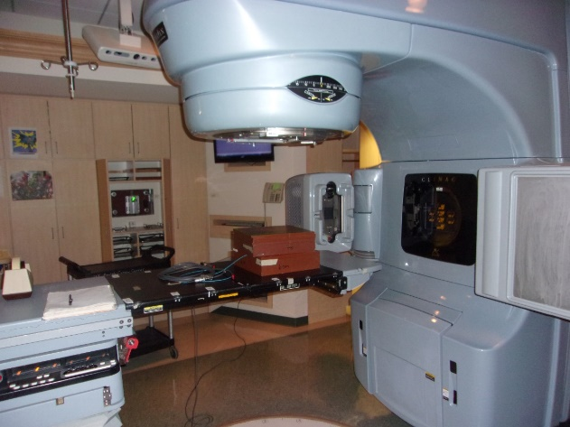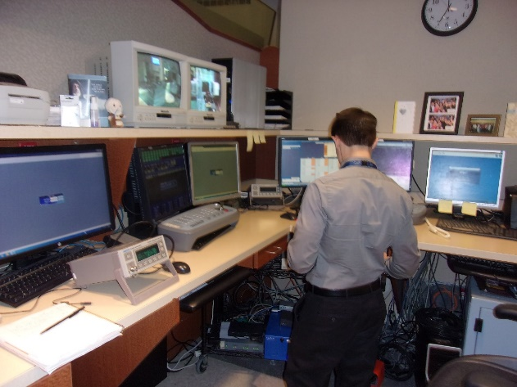
Results:
Table 1: Output recordings
Beam Energy | Non-wedge 10x10 | 30˚ “In” wedged 10x10 | 30˚ “Out” wedged 10x10
6MV Trial 1 | 12.363 | 6.824 | 6.810
6MV Trial 2 | 12.357 | 6.828 | 6.812
6MV Trial 3 | 12.367 | 6.826 | 6.816
10MV Trial 1 | 13.747 | 8.372 | 8.363
10MV Trial 2 | 13.743 | 8.366 | 8.357
10MV Trial 3 | 13.741 | 8.370 | 8.359
*Note: The term “in” denotes a wedge position with the toe closest to gantry and “out” refers to a 180˚ rotation of the wedge with heel closest to gantry with the collimator remaining at 0˚ rotation.

Table 2: Average output
Beam Energy | Non-wedge 10x10 | 30˚ “In” wedged 10x10 | 30˚ “Out” wedged 10x10
6MV | 12.363  12.357  + 12.367  37.087/3  =12.362 avg. nC | 6.824  6.828  + 6.826  20.478/3  =6.826 avg. nC | 6.810  6.812  + 6.816  20.438  =6.813 avg. nC
10MV | 13.747  13.743  + 13.741  41.231/3  =13.744 avg. nC | 8.372  8.366  + 8.370  25.108/3  =8.369 avg. nC | 8.363  8.357  + 8.359  25.079/3  =8.360 avg. nC

Table 3: Wedge factor
Beam Energy | Wedge factor
6MV without wedge  6MV with wedge  Wedge factor | 6.826  ÷ 12.362  .552
10MV without wedge  10MV with wedge  Wedge factor | 8.369  ÷ 13.744  .609

Discussion: The 30˚ wedge factor measured for 6MV photon energy is .552 and the wedge factor for 10MV is .609 taken at a field size of 10x10cm at 10cm SSD. Prior to calculating wedge factor the “In” and “Out” positions of the wedge must be compared to ensure accurate setup and measurement.¹ A difference of greater than 2% indicates a discrepancy in setup or wedge position. Difference of “In” versus “Out” position for 6MV energy is 6.813/6.826=.998 or a difference of less than 1% indicating an accurate setup well within tolerance. The difference for 10MV is 8.360/8.369=.998 also a difference of less than 1% and within tolerance. For comparison shown below are wedge factor tables recorded by my clinical site physics department². My measured wedge factors are within 1% of the clinic documented recordings.
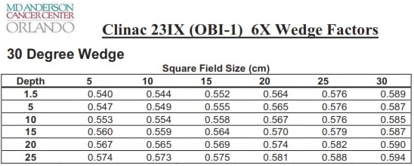
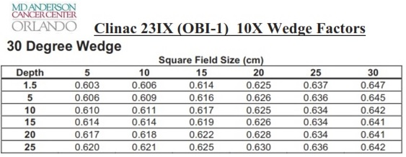
*Note the MD Anderson logo is indicative my facility’s former associations. Currently we are known as UF Health and some of our staff literature and material still retains prior branding.
Clinical application: Kahn and Gibbons explain that the use of a wedge and subsequent reduction in dose when compared to an unwedged field must be factored into radiotherapy treatment calculations.³ We can see the wedge factor at work by examining the following larynx plan prescribed 225cGy daily for 29 fractions at a total dose of 65.25Gy. Four 6MV fields, 30˚ wedged, and equally weighted, were used to achieve the desired outcome. Monitor unit calculation can be carried out using the following formulas.²
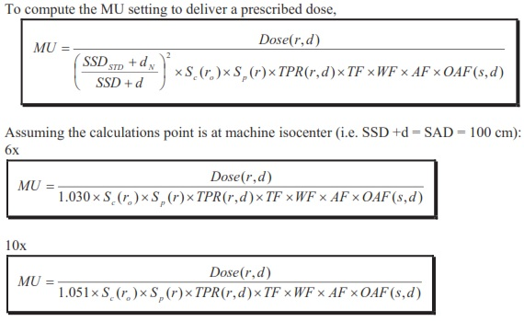

MU hand calc:
Field 1
- Dose=2.25Gy daily/4 fields=56.25cGy
- Blocked eqs= 2(7*4.08)/7+4.08= 5.2
- Sc (from OBI databook²) = requires interpolation: Sc=.967+[(9.2/1)(.978-.9670]=.9692
- Sp (from OBI databook²) =requires interpolation: Sp=.924+[(5.2-5/6-5)(.945-.924)]=.9282
- (SSD_{STD}+d_{N}/SSD+d)²=(100+1.5/100)²=1.030
- TPR (from OBI databook²) = effective depth 4.95 requires interpolation for depth and field size:
-a).894+[(5.2-5/6-5)(.899-.894)]=5.2 field size at depth of 5=.895
-b).910+[(5.2-5/6-5)(.914-.910)=5.2 field size at depth of 4=.911
-c).911+[(4.5-4/5-4)(.895-.911)]=5.2 field size at 4.5 depth= TPR =.903
- Wedge factor= measured value from Table 3=.554
- Wedge off axis distance (from OBI databook²)= 1.1cm OAD; requires interpolation for depth and OAD:
-a) 1+[(1.1-0/2-0)(1.051-1)]= 1.1 OAD at 5cm depth = 1.028
-b) 1+[(1.1-0/2-0(1.057-1]= 1.1 OAD at 1.5 cm depth = 1.031
-c) 1.031+[(4.5-1.5/5-1.5)(1.028-1.0310]= 1.1 OAD at 4.5 cm depth= OAD=1.028
- Calc= 56.25cGy/(1.030)(.9692)(.9282)(.903)(.554)(1.028)=118 MU
- Normalized to 98% isodose line; 118*.98=116 MU

Field 2
- Dose=2.25Gy daily/4 fields=56.25cGy
- Blocked eqs= 2(6.5*4.08)/6.5+4.08= 5.0
- Sc (from OBI databook²) = .967
- Sp (from OBI databook²) =.924
- (SSD_{STD}+d_{N}/SSD+d)²=(100+1.5/100)²=1.030
- TPR (from OBI databook²) = effective depth 3.93 requires interpolation: .
-a) .946+(3.93-3.5/4-3.5)(.928-.946)= .9305
- Wedge factor= measured value from Table 3=.554
- Wedge off axis distance (from OBI databook²)= 1.05->1.1 OAD; per plan requires interpolation for depth and OAD
-a) 1+[(1.1-0/2-0)(1.051-1)]= 1.1 OAD at 5cm depth = 1.028
-b) 1+[(1.1-0/2-0(1.057-1]= 1.1 OAD at 1.5 cm depth = 1.031
-c) 1.031+[(3.93-1.5/5-1.5)(1.028-1.0310]= 1.1 OAD at 3.93 cm depth= OAD=1.029
- Calc= 56.25cGy/(1.030)(.967)(.924)(.554)(.9305)(1.029)=115 MU
- Normalized to 98% isodose line; 115*.98=113 MU

Field 3
- Dose=2.25Gy daily/4 fields=56.25cGy
- Blocked eqs= 2(7*4.08)/7+4.08= 5.2
- Sc (from OBI databook²) = requires interpolation: Sc=.967+[(9.2/1)(.978-.9670]=.9692
- Sp (from OBI databook²) =requires interpolation: Sp=.924+[(5.2-5/6-5)(.945-.924)]=.9282
- (SSD_{STD}+d_{N}/SSD+d)²=(100+1.5/100)²=1.030
- TPR (from OBI databook²) = effective depth 4.33 requires interpolation for depth and field size:
-a).894+[(5.2-5/6-5)(.899-.894)]=5.2 field size at depth of 5=.895
-b).910+[(5.2-5/6-5)(.914-.910)=5.2 field size at depth of 4=.911
-c).911+[(4.33-4/5-4)(.895-.911)]=5.2 field size at 4.33 depth= TPR =.906
- Wedge factor= measured value from Table 3=.554
- Wedge off axis distance (from OBI databook²)= 1.1cm OAD; requires interpolation for depth and OAD:
-a) 1+[(1.1-0/2-0)(1.051-1)]= 1.1 OAD at 5cm depth = 1.028
-b) 1+[(1.1-0/2-0(1.057-1]= 1.1 OAD at 1.5 cm depth = 1.031
-c) 1.031+[(4.5-1.5/5-1.5)(1.028-1.0310]= 1.1 OAD at 4.5 cm depth= OAD=1.028
- Calc= 56.25cGy/(1.030)(.9692)(.9282)(.906)(.554)(1.028)=118 MU
- Normalized to 98% isodose line; 118*.98=116 MU

Field 4
- Dose=2.25Gy daily/4 fields=56.25cGy
- Blocked eqs= 2(6.5*4.08)/6.5+4.08= 5.0
- Sc (from OBI databook²) = .967
- Sp (from OBI databook²) =.924
- (SSD_{STD}+d_{N}/SSD+d)²=(100+1.5/100)²=1.030
- TPR (from OBI databook²) = effective depth 4.03 requires interpolation:
-a) .928+(4.03-4/4.5-4)(.910-.928)= .927
- Wedge factor= measured value from Table 3=.554
- Wedge off axis distance (from OBI databook²)= 1.04 OAD; per plan requires interpolation for depth and OAD
-a) 1+[(1.04-0/2-0(1.051-1]= 1.04 OAD at 5 cm depth = 1.027
-b) 1+[(1.04-0/2-0)(1.057-1)]= 1.04 OAD at 1.5cm depth = 1.023
-c) 1.023+[(4.03-1.5/5-1.5)(1.027-1.023]= 1.04 OAD at 3.93 cm depth= OAD=1.026
- Calc= 56.25cGy/(1.030)(.967)(.924)(.554)(.9305)(1.026)=116 MU
- Normalized to 98% isodose line; 116*.98=114 MU

The effect the wedge has on monitor unit output can be observed by performing the same MU calc without the wedge factor applied. In the table below we observe a ~45% decrease in monitor unit output without the application of the wedge factor. The decrease in output is due to the significant attenuation properties of the steel wedge. As we see here it takes ~45% more MU to deliver the same prescribed dose through the wedge to isocenter. If an MU calc was performed and the wedge factor was mistakenly omitted, the clinical impact would be a 45% under dose to the patient which is significantly out of treatment tolerance accuracy.
MU calc without wedge factor applied | Percent difference
Field 1; 56.25cGy/(1.030)(.9692)(.9282)(.903)(1.028)=65 MU *.98=64 MU | 116-64/116 (*100)=45%
Field 2; 56.25cGy/(1.030)(.967)(.924)(.9305)(1.029)=64 MU*.98=  63 MU | 113-63/113 (*100)=44%
Field 3; 56.25cGy/(1.030)(.9692)(.9282)(.906)(1.028)=65 MU*.98=64 MU | 116-64/116 (*100)=45%
Field 4; 56.25cGy/(1.030)(.967)(.924)(.9305)(1.026)=64 MU*.98=  63 MU | 114-63/114 (*100)=45%
Attached below is a copy of the printed plan monitor unit calculation. One may note that the wedge factor value is not displayed in this planning system. However, wedge data is uploaded by physics into the treatment planning system (TPS) and it is automatically applied by Pinnacle TPS when any wedge is added to a beam.
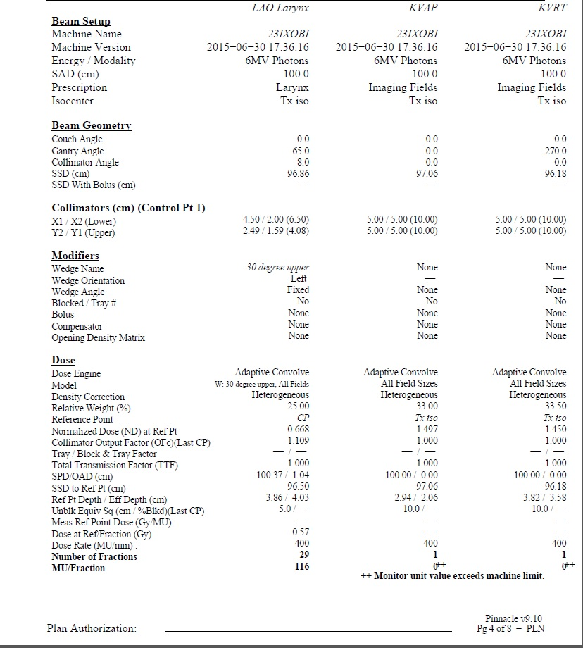
At UF Health Cancer Center all monitor unit second checks are performed using Diamond Calc. All data from Pinnacle is exported to the Diamond Calc independent check system for MU verification. The monitor unit calc of the TPS compared to the Diamond Calc must be within 2% for a plan to be approved for treatment.² Attached below is the second check performed for this plan.
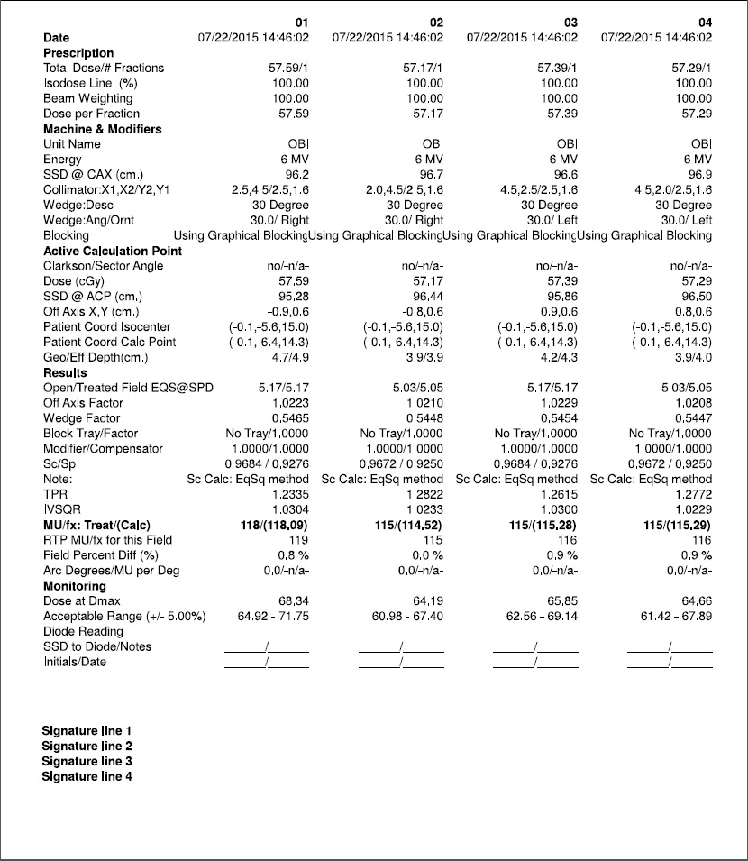
Pictured below is a copy of the treatment plan isodose distribution with 30 degree wedge.
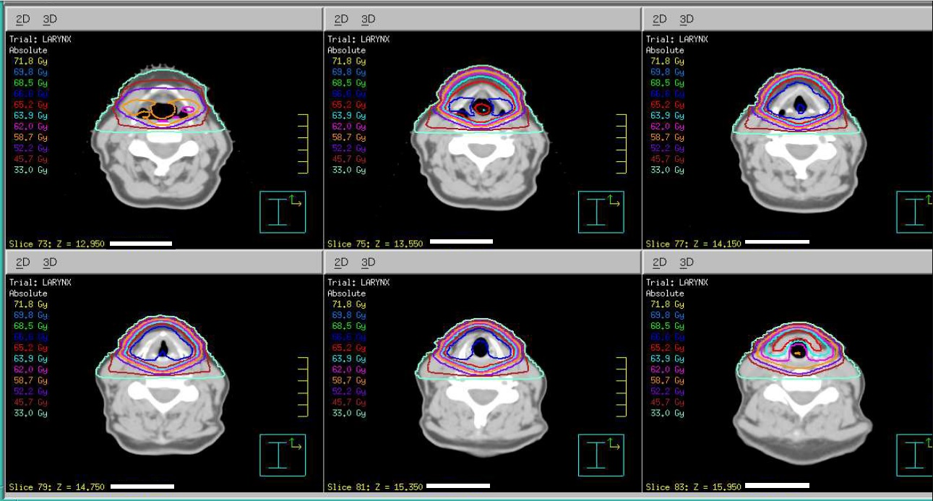
Referenced below are beam’s eye view digitally reconstructed radiographs (DRR) of the wedged fields indicating wedge orientation.
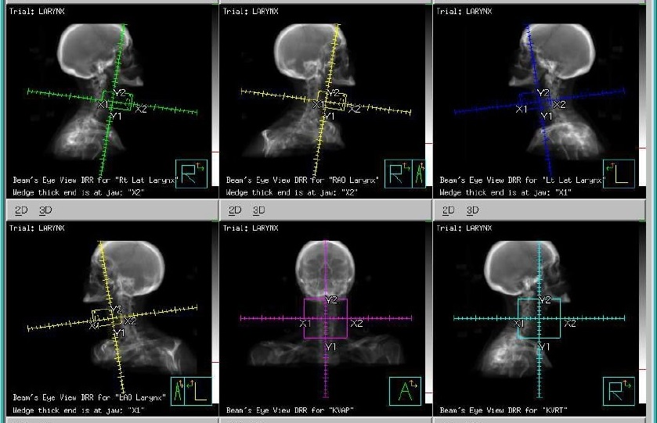
Conclusion: The use of wedges enable corrections to isodose distributions based on patient anatomy and tissue inhommogeneities. As has been seen in the preceding exercise the presence of a wedge can significantly alter the output of a radiotherapy treatment plan. As such, measurements must be taken to compare a standardized open field to a wedged field to determine the effect a wedge will have on the treatment beam. The wedge factor obtained can then be applied to an individualized treatment plan to arrive at an accurate monitor unit setting to deliver an accurate treatment.

References
1. Horton JL. Acceptance Tests and Commissioning Measurements. University of Texas MD Anderson Cancer Center. Houston, TX. http://www-naweb.iaea.org/nahu/DMRP/documents/Chapter10.pdf page 375. Accessed February 25, 2017.
3. Khan FM, Gibbons JP. Treatment Planning I: Isodose Distributions. In: Khan FM, Gibbons JP, ed. The Physics of Radiation Oncology. 5th Philadelphia, PA: Lippincott Williams & Wilkins; 2014:175-182.
2. MD Cancer Center Orlando. Varian 23IX with OBI Dosimetry Manual. UF Health. Orlando, FL. Accessed via local area network Sharepoint. Ferburary 25, 2017.

